Form 421-2
Leadership Performance Evaluation

Employee
Current Role
Date of Report

Purpose - To ensure follow through of service commitments
- To provide accurate appraisal documentation to protect both the employer and the employee
- To ensure the will of the Board of Education is met with respect to foundational statements
- To build self-efficacy and demonstrate the employee’s impact on GSSD Strategic Plan

Cycle of Supervision for Leadership – GSSD has employed a three-year cycle involving conversations, products, and observations. This report will be presented on the 4th year.
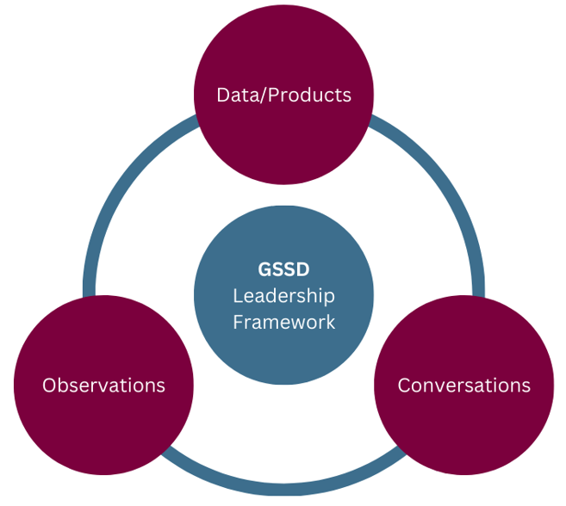

Evaluation Process - A Performance Evaluation Process ensures the work of employees breathe life into the Board of Education's strategic priorities
- There are many approaches to the employee’s evaluation. The contrast appears in the approach and the details. This can make all the difference in how the performance evaluation process is perceived and carried out by employees. This process gathers information through products, observations and conversations connected to:
- This evidence will be gathered over a three-year period and used populate an Overall Performance Evaluation report starting in the employees first year of employment and every third year thereafter. If an employee is failing or improving his job performance, the performance evaluation documentation can be used to develop a Performance Improvement Plan.

Work History - Employee writes their own bio as an introduction.

Education & Recent Professional Development - Employee documents their own educational background, qualifications and professional development opportunities

Personal Information – Employee provides background information on their family, hobbies, interests, etc. The intent is to bring awareness to a work life balance through understanding and knowledge.

Summary Statements
Data Sources | Rubric | Comments & Supporting Artifacts  Resulting from an Analysis of  Data/Products, Conversations and  Observations
Setting Direction | ☐ 1 - Not Meeting Expectations (Removal of Appointment)  ☐ 2 – Progressing  (Performance Improvement Plan Required)  ☐ 3 – Proficient  (Meets expectations)  ☐ 4 – Exemplary  (Model for other GSSD leaders)
Developing People | ☐ 1 - Not Meeting Expectations (Removal of Appointment)  ☐ 2 – Progressing  (Performance Improvement Plan Required)  ☐ 3 – Proficient  (Meets expectations)  ☐ 4 – Exemplary  (Work has been shared as a model for other GSSD leaders)
Leading the Instructional Program | ☐ 1 - Not Meeting Expectations (Removal of Appointment)  ☐ 2 – Progressing  (Performance Improvement Plan Required)  ☐ 3 – Proficient  (Meets expectations)  ☐ 4 – Exemplary  (Work has been shared as a model for other GSSD leaders)
Creating a Learning Organization | ☐ 1 – Not Meeting Expectations (Removal of Appointment)  ☐ 2 – Progressing (Performance Improvement Plan Required)  ☐ 3 – Proficient (Meets expectations)  ☐ 4 – Exemplary (Work has been shared as a model for other GSSD leaders)
Summary Comments

Self-Reflections
Question | Response
What was your greatest personal/professional celebration?
What was your greatest “team” celebration?
What drives you? Choose one or two and explain.
What do you want to be known for? What is your hope for your legacy?

I have read the above report and discussed it with my supervisor. My signature does not indicate that I agree with the contents of the report.
Signatures |  | Date
Employee’s Signature
Supervisor’ Signature

