Form 479-1

EVALUATION FOR ADMIN COUNCIL

Employee | Insert Name
Current Role | Insert Title
Date of Report | 9/19/2022

Purpose - To ensure follow through of service commitments
- To provide accurate appraisal documentation to protect both the employer and the employee
- To ensure the will of the Board of Education is met with respect to foundational statements
- To build self-efficacy and demonstrate the employee’s impact on GSSD Strategic Plan

Cycle of Supervision for Central Office – GSSD has employed a four-year cycle involving conversations, products, and observations
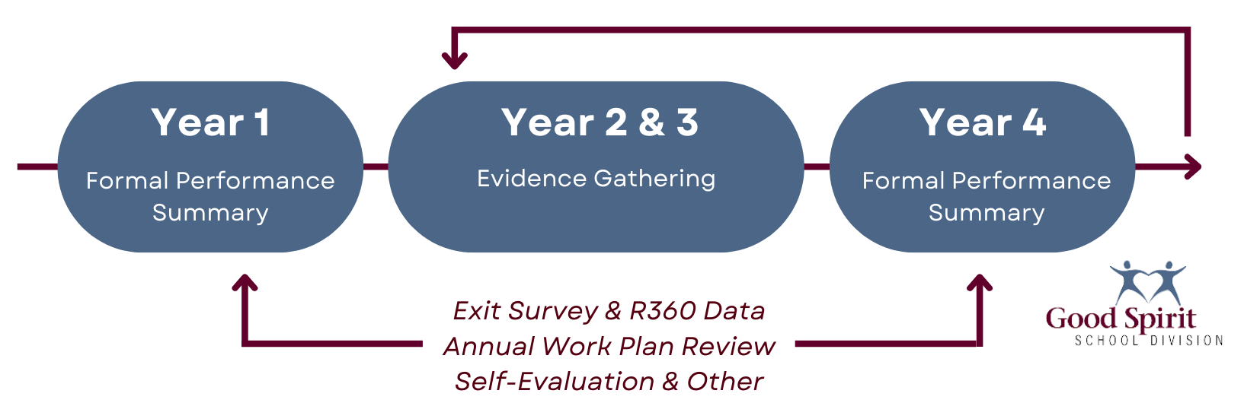

Evaluation Process - A Performance Evaluation Process ensures the work of employees breathe life into the Board of Education's strategic priorities
- There are many approaches to the employee’s evaluation. The contrast appears in the approach and the details. This can make all the difference in how the performance evaluation process is perceived and carried out by employees. This process gathers information through products, observations and conversations connected to:

- Job Descriptions (completed in year of supervision)
- Annual Work Plans (completed annually every 4 months)
- GSSD Service Commitment Reports developed by R360 & Exit Survey Data (completed in year of supervision)
- Annual Self Reflections (completed annually in September)

- This evidence will be gathered over a four-year period and used populate a Performance Evaluation report starting in the employees first year of employment and every fourth year thereafter. If an employee is failing or improving his job performance, the performance evaluation documentation can be used to develop a Performance Improvement Plan.
Work History - Employee writes their own bio as an introduction

Education & Recent Professional Development - Employee documents their own educational background, qualifications and professional development opportunities

Personal Information – Employee provides background information on their family, hobbies, interests, etc.

Summary Statements
Data Sources | Rubric | Comments & Supporting Artifacts
Job Description Fulfillment  (Observations) | ☐ 1 - Not Meeting Expectations (Improvement required)  ☐ 2 – Progressing  (Functioning but not effective)  ☐ 3 – Proficient  (Meets expectations)  ☐ 4 – Exemplary  (Model for other school divisions) | Student Welfare Domain  ☐ YES  ☐ No  - Comments resulting from analysis of the portfolio and local knowledge  Fiscal Responsibility Domain  ☐ YES  ☐ No  - Comments resulting from analysis of the portfolio and local knowledge  Personnel Management Domain  ☐ YES  ☐ No  - Comments resulting from analysis of the portfolio and local knowledge  Policy & Administrative Procedures Domain  ☐ YES  ☐ No  - Comments resulting from analysis of the portfolio and local knowledge  Director/Board/CFO Relations Domain  ☐ YES  ☐ No  Comments resulting from analysis of the portfolio and local knowledge  Strategic Planning & Reporting Domain  ☐ YES  ☐ No  Comments resulting from analysis of the portfolio and local knowledge  Organizational Management Domain  ☐ YES  ☐ No  - Comments resulting from analysis of the portfolio and local knowledge  Communication & Employee/Community Relations Domain  ☐ YES  ☐ No
Effectiveness of Work Plans  (Conversations) | ☐ 1 - Not Meeting Expectations (Improvement required)  ☐ 2 – Progressing  (Functioning but not effective)  ☐ 3 – Proficient  (Meets expectations)  ☐ 4 – Exemplary  (Model for other school divisions) | High Quality Teaching & Learning  Comments resulting from analysis of the portfolio and local knowledge  Engagement of all Students, Families, and Communities  Comments resulting from analysis of the portfolio and local knowledge  Effective Policy & Procedures  Comments resulting from analysis of the portfolio and local knowledge  Healthy Sustainable Physical and Social Environments  Comments resulting from analysis of the portfolio and local knowledge
Service Commitment Analysis through 360 Review Survey Data  (Products) | ☐ 1 - Not Meeting Expectations (Improvement required)  ☐ 2 – Progressing  (Functioning but not effective)  ☐ 3 – Proficient  (Meets expectations)  ☐ 4 – Exemplary  (Model for other school divisions) | The Employee and Supervisor agree upon 10-20 GSSD employees that could provide feedback on the following questions.  HR facilitates the survey and collects the data. Themes and comments are anonymized and summarized.  1. The employee provides clear direction.  Support/Refute/Mixed  2. The employee provides effective leadership in their focus area.  Support/Refute/Mixed  3. The employee establishes and maintains positive working relationships with staff.  Support/Refute/Mixed  4. People trust this employee.  Support/Refute/Mixed  5. The employee empowers others.  Support/Refute/Mixed  6. The employee effectively solves problems.  Support/Refute/Mixed  7. Receiving & Acting on Feedback - When you offer the employee feedback/ideas/concerns either personally or for the school division, were you satisfied with their level of response?  8. Exceeding Expectations - Can you think of a time when this employee went above and beyond in service to you or the school division in general?  9. Single Point of Contact - Are you confident that the employee will be able to get you the support you need either directly or through another team member?  10. Power of 'Yes' - Is there a time when the employee sought a solution rather than just denying the request?  11. Express Empathy - Has the employee provided you support when you were in a difficult spot personally or professionally?  12. Caring & Friendly Attitude - Having a caring and friendly attitude is important for the leadership of GSSD? Would you consider the employee to be caring and friendly?  13. Taking the Time to Listen - Listening is a skill that goes beyond 'hearing'. It involves validating the voice of others.
Overall Impact to GSSD | ☐ 1 - Not Meeting Expectations (Improvement required)  ☐ 2 – Progressing  (Functioning but not effective)  ☐ 3 – Proficient  (Meets expectations)  ☐ 4 – Exemplary  (Model for other school divisions)

Self-Reflections – Feedback for Supervisor
Question | Response
What was your greatest personal/professional celebration?
What was your greatest “team” celebration?
What drives you? Choose one or two and explain.
What do you want to be known for? What is your hope for your legacy?

I have read the above report and discussed it with my supervisor. My signature does not indicate that I agree with the contents of the report. In accordance with GSSD Administrative Procedures, I understand that I have fourteen (14) days following this review to submit a written rebuttal if I feel this document inaccurate or unfair.
Signatures  (The supervisor should SAVE to PDF when complete and request digital signatures.) |  | Date
Employee’s Signature
Supervisor’s Signature

