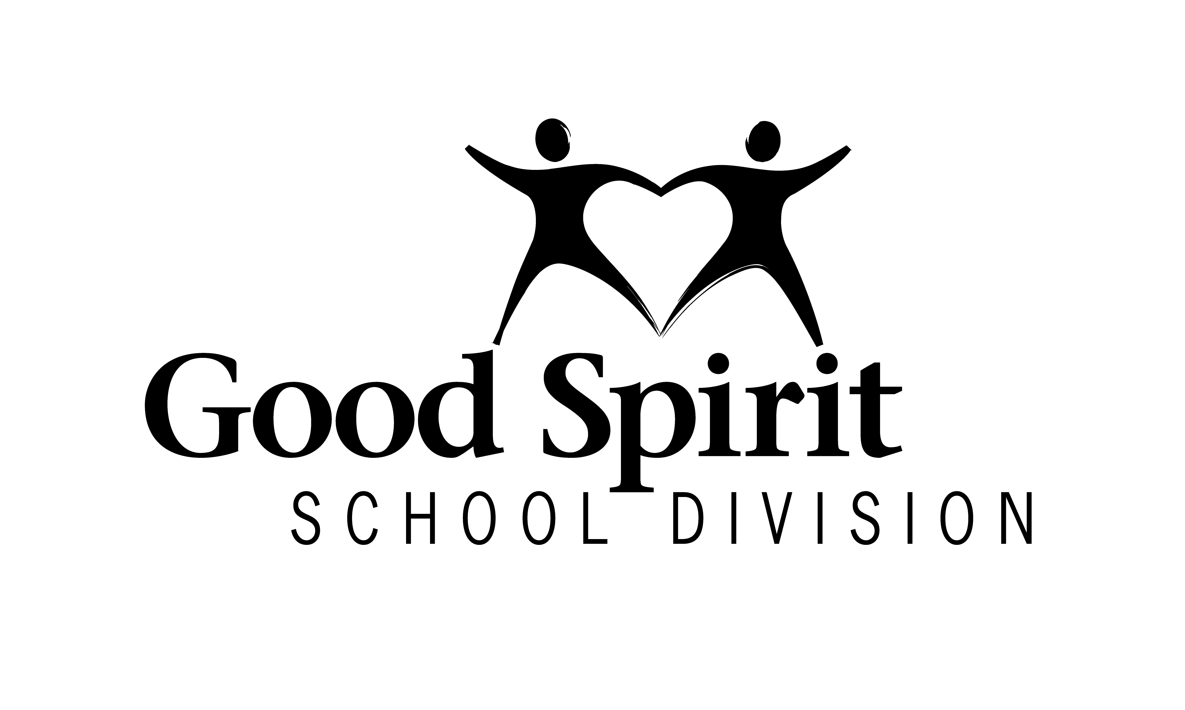
Our Motto Students Come First
Our Mission Building Strong Foundations to Create Bright Futures
Our Values Belonging, Respect, Responsibility, Learning, Nurturing and Perseverance
Our Vision Learning Without Limits…Achievement For All

Payroll Assistant

Portfolio: | Payroll, Pension & Benefit Processing
Reports Directly to: | Payroll Supervisor
Reports Indirectly to: | Chief Financial Officer
Direct Reports: | 0
Department/Location: | Payroll/Good Spirit Education Complex – Yorkton, SK
Salary Range: | Payroll Assistant Grid – 5 steps
Last Updated: | October 17, 2022

Position Profile:

- Guided by the Good Spirit School Division’s foundational statements, the Payroll Assistant is a key resource responsible for the timely and accurate processing of payroll. The Payroll Assistant assists the Payroll Supervisor in achieving the general and specific requirements of their work, all while being compliant with applicable legislation and in accordance with the terms and conditions of the respective contracts and agreements. The Payroll Assistant will represent the Division in a positive, ethical, professional manner and serve as a primary point of contact to staff in a variety of functional areas such as compensation, benefits, leave utilization, accrual records and pension administration. The position works toward 4 strategic focus and long-term goals: Student & Family; Internal Process; People Capacity and Financial Stewardship.

Duties & Responsibilities
Without restricting the generality of the overview above, the Payroll Assistant shall perform such duties and responsibilities as may be assigned including but not restricted to the following:
- Develop payroll estimates and statistics as required including estimates for contract negotiations and annual budget preparation.
- Prepare and maintain all employee payroll records.
- Produce all payroll vouchers.
- Electronically transmit payroll.
- Prepare payroll summaries and remittances.
- Produce T4 returns.
- Prepare monthly or annual reports.
- Enroll employees in the appropriate benefit and pension plans.
- Prepare Record of Employment forms in accordance with legislation as required.
- Clerical Responsibilities
- Develop and maintain filing systems, ensuring confidentiality for staff members.
- Prepare reports, letters, remittances, and documents relative to the Payroll Assistant position.
- Performs other duties and obligations as assigned by the Payroll Supervisor or the Chief Financial Officer.

Education and/or Experience

- Minimum Grade 12 or equivalent
- Diploma/Certificate in Accounting/CPA or related post-secondary program

Knowledge, Skills and Abilities

- Quality & Organization of Work
Demonstrates the ability to independently initiate and organize projects to achieve work process efficiencies, pay attention to detail and ensure work is accurately completed within expected timeframes.

- Adaptability & Flexibility
Demonstrates the ability to prioritize multiple demands and effectively manage time while being responsive to changing priorities. Flexibility entails understanding and appreciating differing perspectives on an issue and adapting one’s approach as the requirements of a situation change. Strong problem-solving skills and the ability to apply judgement in complex, highly sensitive and sometimes ambiguous situations is essential.

- Communication
Must have superior interpersonal and communication skills and be able to communicate professionally with administration and staff, all while representing Good Spirit School Division in a positive manner.

- Cooperation & Teamwork
Ability to work with staff and provide appropriate information and support in a timely manner. The position must have the ability to work as a team player or independently.

- Attitude
Must present a positive and professional attitude towards others, their work, and the division and conduct oneself in an appropriate manner. The position promotes the GSSD values of belonging, respect, responsibility, learning, nurturing and perseverance.

- Confidentiality
At no time should the Payroll Assistant discuss, in public, information pertaining to employees, students or the operation of the Division. Employees are expected to respect the confidential nature of their position by avoiding discussion about any topics not formally communicated to the public by the administration of the school or the School Division. Breaching confidentiality is a serious violation of acceptable conduct and The Local Authority Freedom of Information and Protection of Privacy Act.

