Form 479-4

Building Strong Foundations to Create Bright Futures
Learning Without Limits ... Achievement For All

Professional Service Provider Evaluation Report

Employee
Current Role
Date of Report

Purpose - To ensure follow through of service commitments
- To provide accurate appraisal documentation to protect both the employer and the employee
- To ensure the will of the Board of Education is met with respect to foundational statements
- To build self-efficacy and demonstrate the employee’s impact on GSSD Strategic Plan

Cycle of Supervision for PSP employees – GSSD has employed a four-year cycle involving conversations, products, and observations
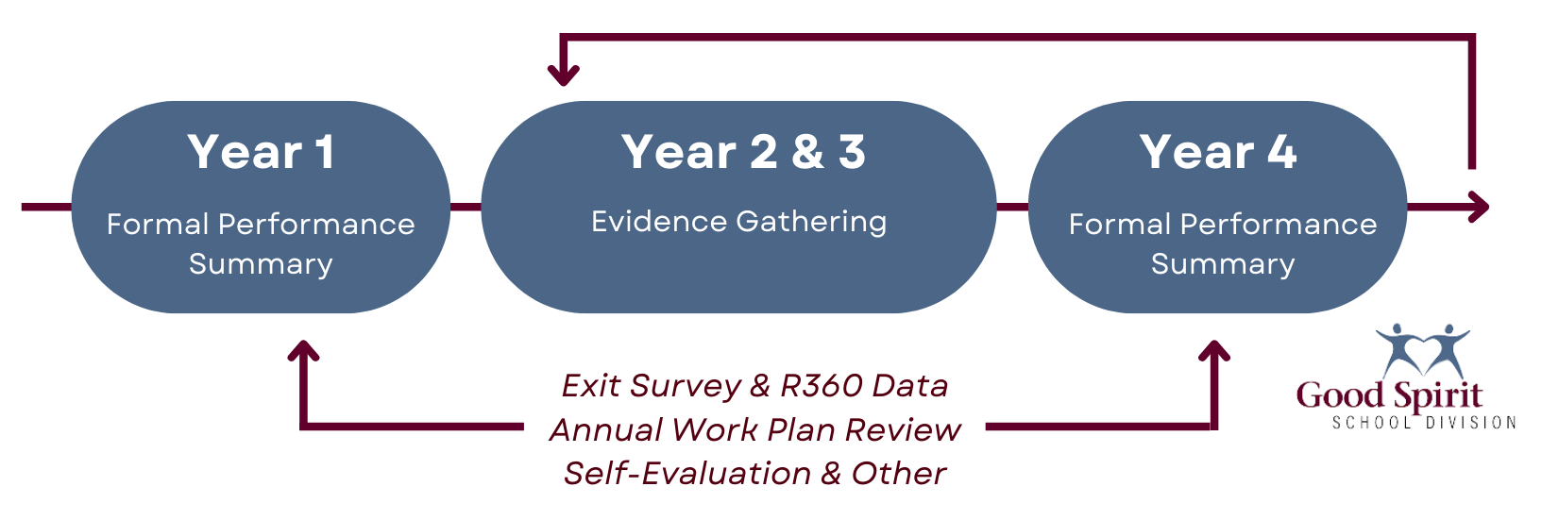

Evaluation Process - A Performance Evaluation Process ensures the work of employees breathe life into the Board of Education's strategic priorities
- There are many approaches to the employee’s evaluation. The contrast appears in the approach and the details. This can make all the difference in how the performance evaluation process is perceived and carried out by employees. This process gathers information through products, observations and conversations connected to:

- Annual Work Plans (completed annually)
- GSSD Service Commitment Reports developed by R360 & Exit Survey Data (completed in year of supervision)
- Annual Professional Growth Plans & Self Reflections (completed annually in October)

​​​​​​​The criteria used to evaluate PSP’s is outlined in the GSSD Student Services Pillars for Success. GSSD believes in supporting student diversity and promoting exemplary practices through the use the 4: Communication, Collaboration, Capacity Building and Consistency of Practice.
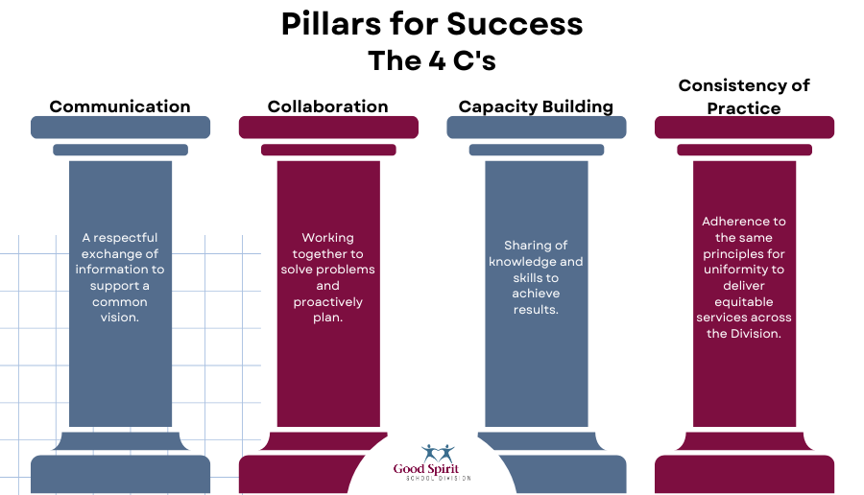
Evidence will be gathered over a four-year period and used populate a Performance Evaluation report starting in the employees first year of employment and every fourth year thereafter. If an employee is failing or improving their job performance, the performance evaluation documentation can be used to develop a Performance Improvement Plan.

Work History - Employee writes their own bio as an introduction

Education & Recent Professional Development - Employee documents their own educational background, qualifications and professional development opportunities

Personal Information – Employee provides background information on their family, hobbies, interests, etc.

Summary Statements:
 | Rubric | Comments & Supporting Artifacts
Collaboration | ☐ 1 - Not Meeting Expectations (Improvement required)  ☐ 2 – Progressing  (Functioning but not effective)  ☐ 3 – Proficient  (Meets expectations)  ☐ 4 – Exemplary  (Model for other school divisions) | Evidence of Collaborative Service Delivery withing GSSD  ☐ YES  ☐ No  Contribution to Discussions and Problem Solving  ☐ YES  ☐ No  Addressing Challenging Situations in a Collaborative Manner  ☐ YES  ☐ No  Flexible Thinking regarding Various Perspectives  ☐ YES  ☐ No
Comments

Consistency of Practice | ☐ 1 - Not Meeting Expectations (Improvement required)  ☐ 2 – Progressing  (Functioning but not effective)  ☐ 3 – Proficient  (Meets expectations)  ☐ 4 – Exemplary  (Model for other school divisions) | Compliance with required referral documentation, tracking notes, etc…  ☐ YES  ☐ No  Completion of a Professional Growth Plan  ☐ YES  ☐ No  Creating and Sharing Reports  ☐ YES  ☐ No  Identification of Gaps/Needs  ☐ YES  ☐ No  Establishment of Plan with School/Division Team and Parents  ☐ YES  ☐ No  Implementation of Plan  ☐ YES  ☐ No  Monitoring of Progress and Review of Plan  ☐ YES  ☐ No  Collaboration in the Development of the IIP  ☐ YES  ☐ No  Supports and Services Alignment with IIP Goals  ☐ YES  ☐ No
Comments

Capacity Building | ☐ 1 - Not Meeting Expectations (Improvement required)  ☐ 2 – Progressing  (Functioning but not effective)  ☐ 3 – Proficient  (Meets expectations)  ☐ 4 – Exemplary  (Model for other school divisions) | Professional Reading and Research Trends in Education and/or Chosen Discipline  ☐ YES  ☐ No  Professional Development Focus  ☐ YES  ☐ No  Providing Professional Development to Build the Capacity of Others  ☐ YES  ☐ No  Enhancing Professional Knowledge and Refining Practice  ☐ YES  ☐ No  Professionalism  ☐ YES  ☐ No
Comments

Communication | ☐ 1 - Not Meeting Expectations (Improvement required)  ☐ 2 – Progressing  (Functioning but not effective)  ☐ 3 – Proficient  (Meets expectations)  ☐ 4 – Exemplary  (Model for other school divisions) | Demonstration of Effective Communication Skills  ☐ YES  ☐ No  Timely Response to Requests for Communication  ☐ YES  ☐ No  Inter-Professional Approach to Communication  ☐ YES  ☐ No
Comments

Overall Impact to GSSD | ☐ 1 - Not Meeting Expectations (Improvement required)  ☐ 2 – Progressing  (Functioning but not effective)  ☐ 3 – Proficient  (Meets expectations)  ☐ 4 – Exemplary  (Model for other school divisions) | - Comments

Self-Reflections – Feedback for Supervisor
Question | Response
What was your greatest personal/professional celebration?
What was your greatest “team” celebration?
What drives you? Choose one or two and explain.
What do you want to be known for? What is your hope for your legacy?

I have read the above report and discussed it with my supervisor. My signature does not indicate that I agree with the contents of the report. (The supervisor should SAVE to PDF when complete and request digital signatures.)
Signatures |  | Date
Employee’s Signature
Supervisor’s Signature

